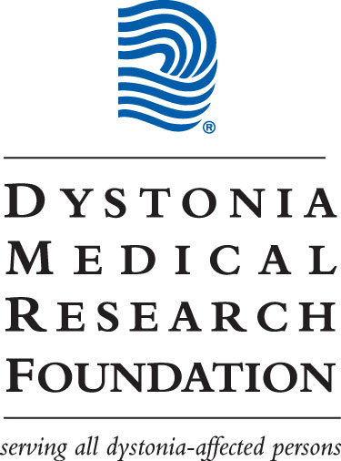

Dystonia Medical Research Foundation

Final Report for Grants and Fellowships

In order to better monitor the progress of research projects, the Foundation requires an interim progress report. Please discuss, in 3 pages or less, the progress to date regarding the specific aims and milestones outlined in your application and whether the purpose and the aims will be reached. If any deviation is projected, indicate the reasons for this.

Title of Grant or Fellowship: Unraveling hierarchical network loops in isolated dystonia

Principal Investigator: Xin Jin

Budget: $129,613

The fund was utilized in the following way: Postdoc salary, supplies and mice

Final report:

1. We have recorded the neuronal activity in thalamus including VL and thalamic parafascicular nucleus (PF) to dissect the dystonia-related network activity. The PF was selectively targeted through injecting retro-AAV-Cre into the dorsal striatum (Fig. 1A-B). The electrode array was implanted into PF and the neuronal activity of PF neurons during each lever pressing in the action sequence was analyzed. We found that both VL and PF increase firing rate during repetitive actions (Fig. 1C-D).
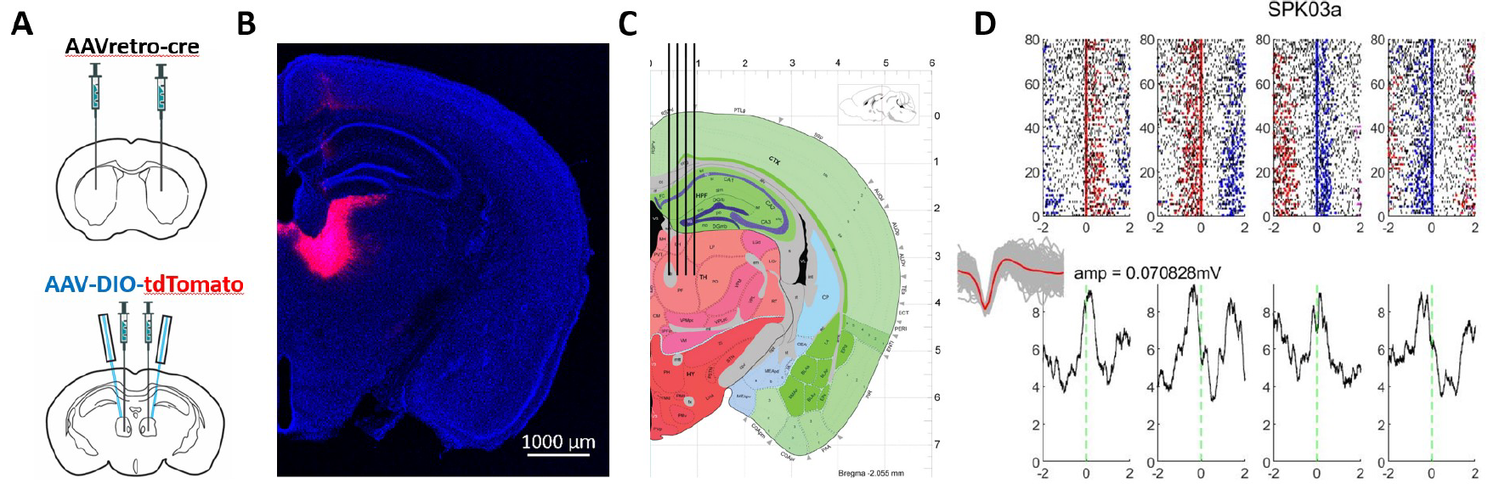
Figure 1. Selectively targeting thalamic nucleus and neuronal activity in PF during lever pressing action sequence in freely behaving mice. (A) Strategy for selectively targeting PF. (B) Histological results of PF. (C) Electrode array for targeting PF for in vivo recording. (D) Neuronal activity of a PF neuron during each lever pressing of the action sequence.

2. To disrupt pathological activity in the thalamus and assess the impact on symptoms, we have successfully expressed both channelrhodopsin-2 and halorhodopsin in ventral lateral nucleus (VL) of thalamus and tested the effects of optogenetic stimulation or inhibition of VL on locomotion and learned motor sequence behavior. These experiments have demonstrated that selectively targeting and manipulating individual motor thalamic nucleus using genetic approaches through either VGluT2-cre or retro-AAV in motor cortex (Figure 2).

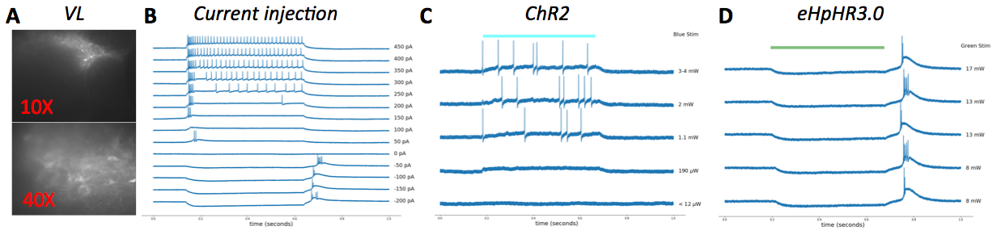
Figure 2. Selective targeting VL neurons and validation of the optogenetic manipulation in brain slice. (A) Retrograde labeling of VL neurons through injecting retro-AAV-Cre into motor cortex and AAV-FLEX-GFP in VL. (B) A typical VL neuron’s response to various current injections. (C) VL neuron response to 500ms optogenetic excitation by expressing ChR2. (D) VL neuron response to 500ms optogenetic inhibition by expressing eNpHR3.0.

3. To disrupt pathological activity in the motor thalamus and assess the impact on dystonia symptoms,
we have recently successfully expressed both channelrhodopsin-2 and halorhodopsin in ventral lateral
nucleus (VL) of thalamus. The VL was selectively targeted through injecting retro-AAV-Cre in primary motor cortex, and effects of optogenetic manipulation of VL on locomotion and learned motor sequence behavior were tested. Notably, it has also showed the general effects of VL excitation or inhibition on locomotion and learned motor behavior in healthy animals, which provides crucial insights into how to disrupt the pathological activity of the motor thalamus in the dystonia brain and rescue the dystonia symptoms based on restoring the normal network physiology. Specifically, we found that inhibition of VL during operant lever pressing under a schedule mimicking Dystonic tremor (finishing four presses within 1s, FR4/1s) can dramatically suppressing the actions (Figure 3). This is likely a very important result that has promising therapeutic implications for treating Dystonia.

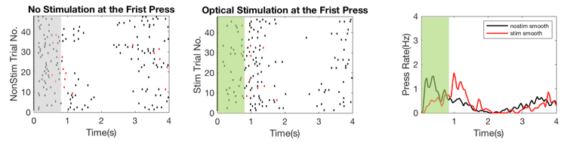
Figure 3. Selective inhibition of VL suppresses tremor-like ultrafast actions in freely behaving mice. (Left panel) Trial-by-trial plot of mouse behavior during FR4/1s schedule of control trials without optogenetic stimulation, where the animal was required to finish four lever pressing within 1s to gain pellet reward. Each dot indicates a lever press and red dot indicates the rewarding press. (Middle panel) Trial-by-trial plot of the same animal’s behavior in the same session with optogenetic inhibition of VL in 50% trials. (Right panel) Peristimulus time histogram (PETH) of the press rate in opto vs. control situation.

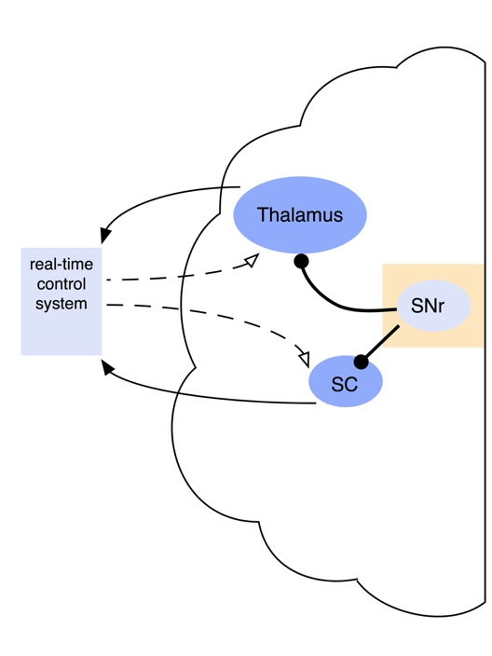
4. For the future work, we expect to conduct additional in vivo electrophysiological and optogenetic experiments, following the results from current project, expecting to understand the different contribution of SC, SNr and thalamus in the network dynamics and their respective role in dystonia. At the same time, we expect to eventually build a network model based on known anatomical and experimental data so that we gain better understanding on the network dynamics and how it contributes to motor control. These results will together reveal how the basal ganglia, thalamus and SC networks control voluntary vs. involuntary actions in health and disease, particularly for dystonia (Figure 4).

Figure 4. Schematic of closed-loop system for blocking impending BEB symptoms.

Signed: ________________________________ Date: __12/5/2021_______

Please return this report to Jody Roosevelt
at the Dystonia Medical Research Foundation, One East Wacker Drive, Suite 1730, Chicago, IL 60601
Phone: 312-755-0198 • Fax: 312-803-0138 • E-mail: jroosevelt@dystonia-foundation.org

